
Pass the SALT 2019

Conference report
August, 2019

You will find below the final report of the Pass the SALT 2019 conference, in which we will detail:
- the attendance,
- the exposure received by the sponsors and the conference,
- the content of the conference,
- the 2019 speakers feedback,
- the improvements made in 2019 following the feedback of the 2018 attendees,
- and finally, the feedback from 2019 attendees.

SYNTHESIS
- Content and sharing : the conference was sold out (240 seats) and it allowed us to share high quality content about Security and Free Software without any restriction or barrier (free entrance, streaming, slides and talks recording available online).
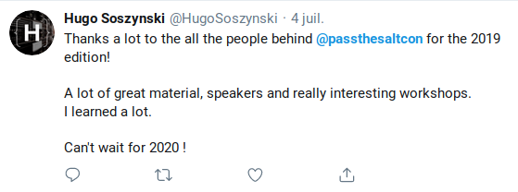
- Experience : 97% of the attendees describe (through the post event survey) their experience as wonderful or very good.
- Exchange : a lot of new interactions between people coming from very different locations and backgrounds (professional, communities) have been made possible.
We really want to thank you for your support which makes all of this possible!

1. Attendance
- 240 people booked their seat. The conference was sold out.
- Finally, 185 people came to get their badge (no show : ~23%)
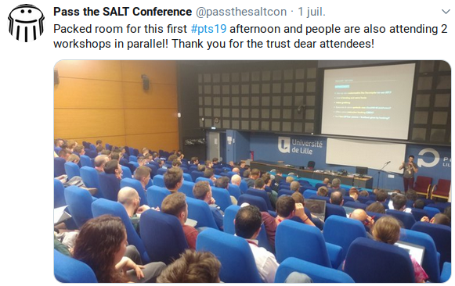
Geographical distribution of the attendees:
source: post event survey
- France: 78% (Lille area: 25%, rest of France: 53%)
- Europe: 17%
- Rest of the world: 5%
Language : attendees that can speak French: 85% , others: 15% .
source: booking form
Attendees already there in 2018: 24%
source: booking form
It may be explained as we added 40 more seats.
We were really happy to see new people joining us!
Occupation:
source : booking form
- private sector: 50%
- public sector: 16%
- students: 13%
- academic: 5%
- others: 6%

2. Sponsors and conference exposure
- Twitter :
  - we posted an announcement on the conference Twitter account as soon as we received the support confirmation of a sponsor,
  - several reminders of the sponsors list have been posted all along the event preparation and at the end of the event:
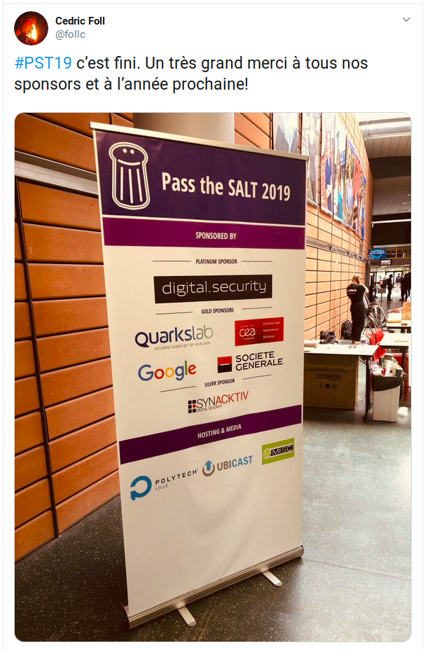
- 2 roll-ups :
A roll-up was at the reception desk (see photo) and one other was on stage near the speakers.
- During the conference and in the video recording :
  - Citation during the event: all the sponsors have been cited during the launching talk and during the organizers lightning talk.
  - Citation inside each video recording: the introduction of each video exposes the list of sponsors. Example : 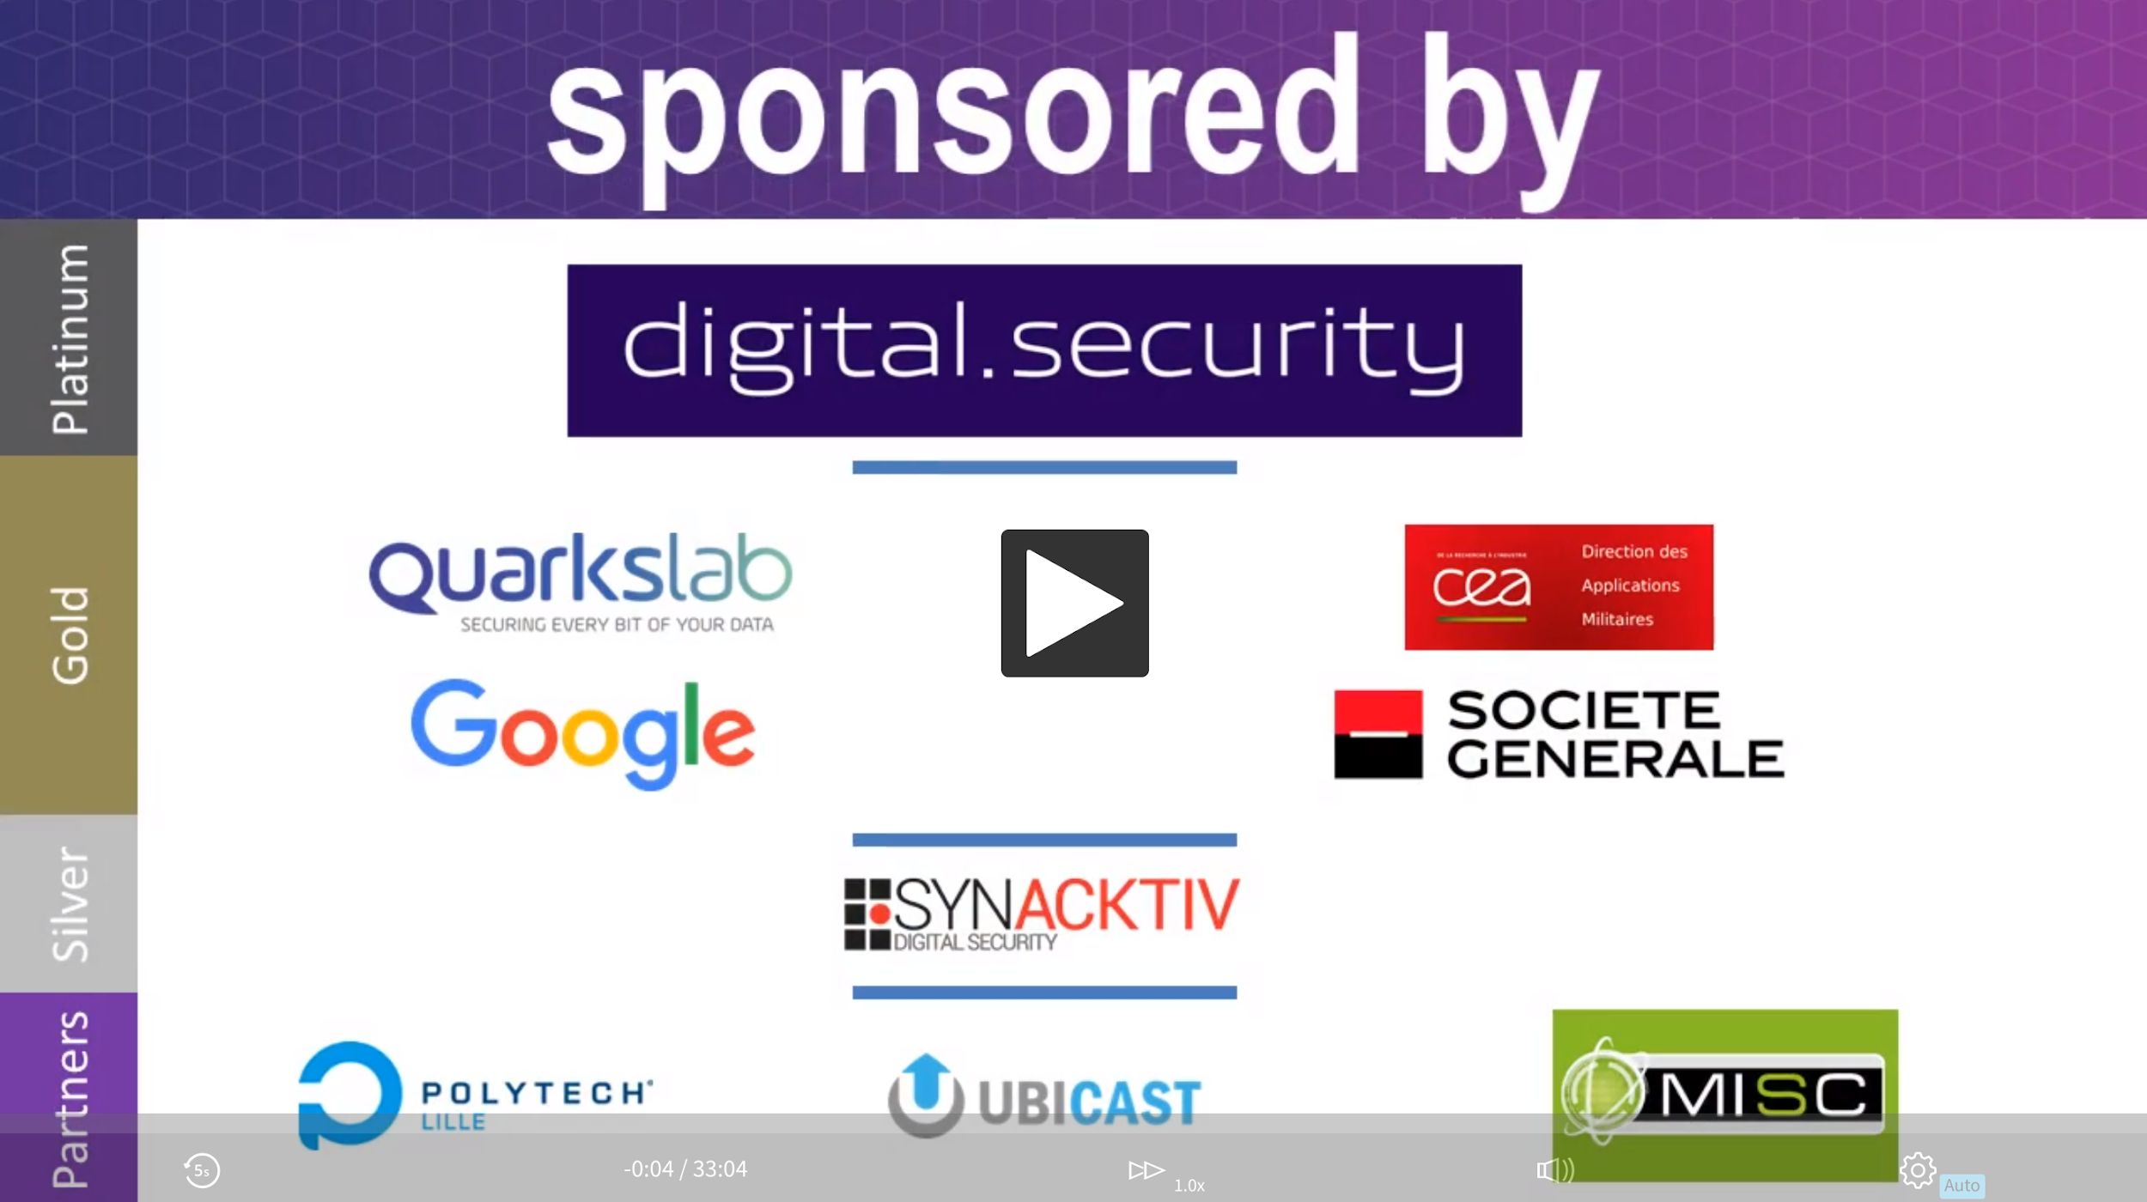
2 months after the event, these videos have accumulated 1248 views.
- Media:
- Conference reports:
  - Xavier Mertens, DFIR expert: https://blog.rootshell.be/2019/07/04/pass-the-salt-2019-wrap-up/
“To conclude, three intense days with many talks (the fact that many of them were 20-mins talks, the schedule may contain more), relaxed atmosphere, good environment. It seems to be a “go” for the 2020 edition!”
  - Anisse Astier, embedded Linux kernel developer at Freebox :
part 1, part 2 and part 3.
- Twitter : twitter feed of the event

3. The conference
The event took place at the Lille Polytech engineering school from the 1st to the 3rd of July, 2019 and has provided:
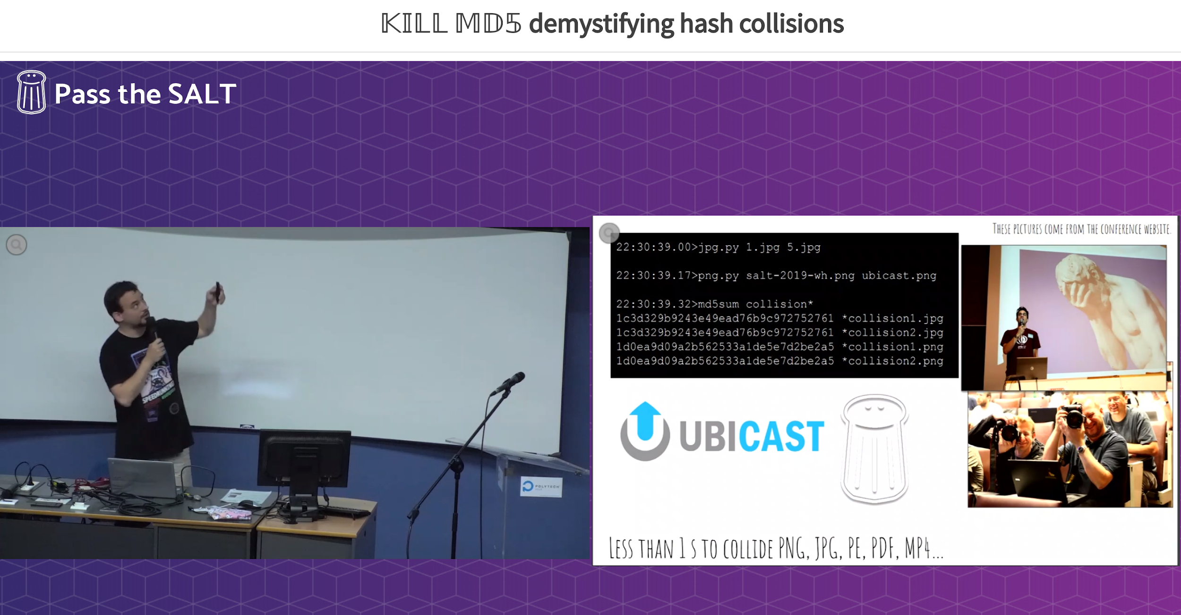
- 26 talks (35min or 20min long)
Ange Albertini, “Kill MD5” talk
- 9 workshops (4 more than in 2018). Most of them have experienced a good attendance (between 15 and 20 attendees, 20 was the maximum possible).
- Speakers geographical distribution:
  - France : 55%
  - Europe: 34%
  - Rest of the world: 11%
- Vidéo : talks have been streamed and recording were online 2 days after the event.

4. 2019 speakers Feedback
You will find there the feedbacks from some of the speakers of the 2019 edition.
Orange Tsaï (Principal security researcher at DEVCore, best server side bug at @PwnieAwards 2019)
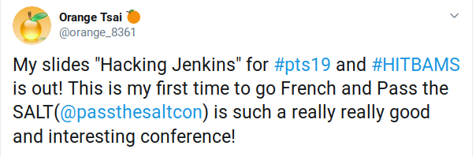
Note : although he is a regular at the biggest offensive security conferences (BlackHatUSA, HITB AMS etc), Orange sent a message of thanks to the organisation (1st time he did it according to him) for the quality of the conference as well as the support he had received. We have been touched by this attention, which we take as a sign of the quality of the conference and we share it with you..

Ange Albertini (security researcher at Google, member of the team behind practical attack against SHA-1)
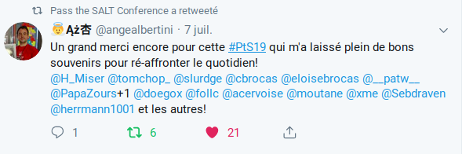

L’équipe du CIRCL (CERT Luxembourg for private sector) that exposes their D4 project
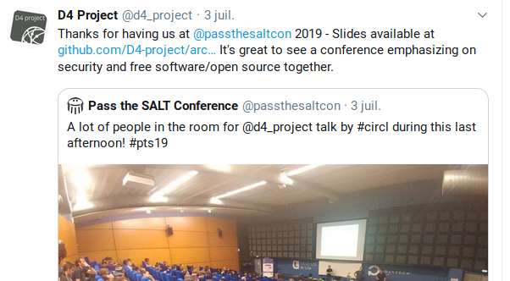
The team designing and producing Proxmark3 (talk+ workshop about Proxmark3)
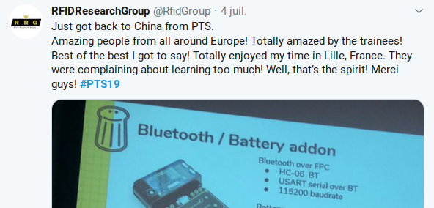

5. 2019 improvements after 2018 attendees feedback
Before speaking about 2019 feedback, let’s give a look at the suggestions given by 2018 attendees and answers we provided this year:
Practical side:
- Air conditioning. Investigate possibilities to cool down the room → We investigated but it was impossible to install an AC unit. Weather was on our side this year (limit but OK).. Some fans had been installed in the workshop rooms.
~OK
- WiFi. Get a less filtered Internet access → a full access WiFi has been setup for each attendee who has asked for it during the booking process (Polytech network team requirement). After some tuning during the first afternoon, everything went fine.
OK.
- Rump session. Improve rump session fluidity, try to get a maximum of slides on the same machine → Everything has been fluid due to the majority of the slides decks were already on the presentation laptop.
OK.
- Social event. Improve the design of the social event coins in order to better prevent their loss → The coins were on the badge this year. But the attachment was not robust enough. We have to work on the design to improve it.
In progress.
- Social event. Modify the social event setup to improve the mobility of the attendees → Nothing has been done on it this year..
To be improved.
- On site info. The schedule and information for wifi printed on posters big enough to be read from afar → Schedule and WiFi posters were on the wall at the reception desk and inside the talks and workshops rooms.
OK.
- Pauses. Improve the pauses content. → We have changed the provider (no choice). It was less expensive but the content has to be improved.
To be improved.
- Non FR people experience. Improve networking experience for non-French speaking people → We added an English flag on the badge of people who told us during the booking process they are not at their ease speaking French. We also asked the attendees to switch to English when they see such flag.
In progress.
- Lunch. Before each day mid-day break, explain how to find the restaurants location → Last year, the only option was a 5 to 10min walk to Pierre Mauroy stadium to reach restaurant and take away food stores. This year, we added 2 food trucks to this first option.
OK.
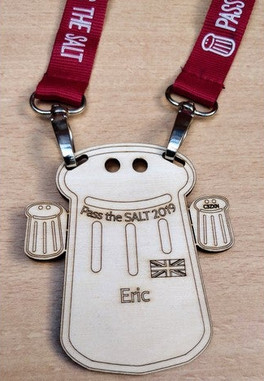
- Desk. Set up reception desk opening (and closing!) hours → Finally the desk stayed open all along the 3 days and the check in was really fluid due to the tickets scan through smartphone application we used.
OK.
- Badge. Have a way to prevent badge flipping / allow to add some information on them (personal information like project, twitter handle, company, languages spoken etc) → The badge design provided good answers to these problems. But we have to improve the solidity of the 2 attachment points.
~OK.
Suggestions about talks and workshops:
- Add several other talk formats in order to avoid talks tunnel: roundtable, projects/tools demos etc. → We do not address this need this year. We have worked to improve the diversity of topics but not their format.
To be improved.
- Have talks more specifically focused on Free Software specific aspects: life of a project, licenses, etc. → We had a talk about (negative/toxic) impact of infosec as a community on a major FLOSS project (VLC) and a talk about independence and FLOSS.
OK.
- Less talks in order to be able to propose a less dense schedule and have more time for chitchat. Start later would also ease the access to the venue which is 30 min away from the center of Lille → We have decreased slightly the number of talks and have started the first talk of each day 40 min later than in 2018.
OK.

6. 2019 attendees Feedback
Note : figures come from the post event survey to which 45% of the attendees answered (83 people on a total of 185).
Overall appreciation
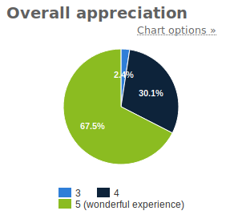
With more than 67% of the attendees who have lived a wonderful experience and 97% of them who have lived a good to wonderful experience, we are satisfied. Let’s have a look at what people liked and what they want to improve :-)
How long did people stay
source : sondage avec 83 participants
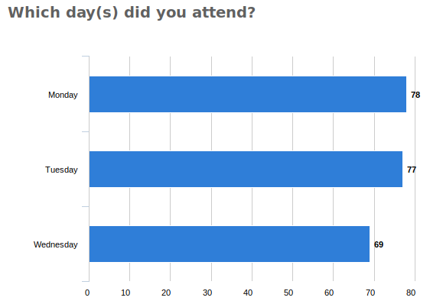
A vast majority of people stay all along the conference. We can state that the topics of the conference were coherent and attractive enough to convince people to dedicate three days to the conference.

What have been most appreciated
source: survey with 83 participants (for 185 attendees)
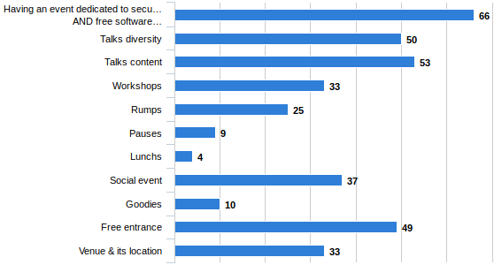
Analyze :
- Security and Free Software: the main topic of the conference seems to be attractive enough to find its public and see registration figures increase. We'll keep going on!
- Free access is appreciated and we are happy! Freedom of access allows students or low income people to attend high quality talks and so, meets the philosophy of sharing and collaboration behind Free Software.
- Diversity and content of talks : 60%+ of attendees appreciated them. It is interesting to note that aspect while a lot of very specialized conferences appear. We also have to note that 3 sessions have a priori some difficulties to find their audience.
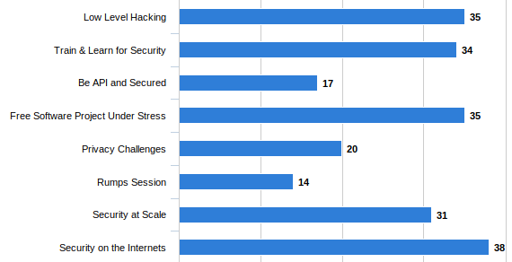
Individual feedback exploitation :
- Talks/workshops: the high technical level of most of the talks and the diversity of the schedule (7 sessions) have been pointed as key elements of attractiveness. Talks provide an easy and free access to quality content to the audience.
Workshops are also popular for giving access to quality know-how as reported there:
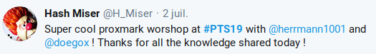
- Exchanges: having the opportunity to exchange with people coming from very diverse horizons and backgrounds and also with very accessible speakers has been very appreciated. Social event and mid day pauses have been pointed as good opportunities to socialize.
- Lunch: food trucks added just in front of Polytech school, providing accessible food, have been seen as a good addition to existing catering offering around Pierre Mauroy stadium.
- Freedom of access and the value of having a conference mixing Security and Free Software are 2 points that came up very often in the free comments in addition to the predefined choice answers.

Improvements and new features
source: survey with 83 participants (for 185 attendees)
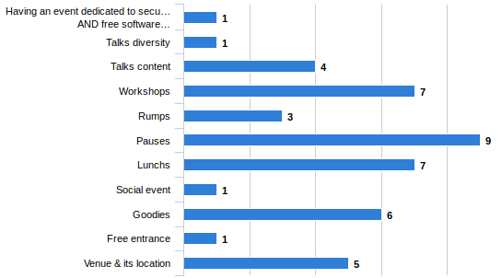
Analyze:
The first thing to mention is that the most commented topic only reach 11% of the attendees and the following two reach 8%. Really problematic topics are very few. Let’s give a look at the individuals proposals from this year attendees.
Individual feedback:
- Talks: some comments pointed out that two talks had given too much importance to the promotion of their company and that one of them was borderline on the Free Software aspect. That was also our feeling. However, it is not easy to prevent this because, of course, it does not appear in the content of the submissions to the CFP.
Actions 2020 :
  - Free Software side of the proposal: we will be really attentive to the profile of the speaker and the company behind him/her.
  - Company description slide: we will also provide a strong reminder to the 2020 speakers to limit the company mention to one single slide.
  - Some initiatives for talks and workshops:
    - Talk evaluation/feedback: as suggested by some attendees, we will look at the possibility to provide this feature.
    - Level: we will indicate the level of the different workshops.
    - Capture The Flag challenge : if someone wants to make and animate it, why not?
- Pauses: their content did not convince. Some coffee would have been appreciated after lunch.
Actions 2020 :
  - Coffee: we will try to see if it is possible for us to have it.
  - Pauses content: we will try to improve it.
  - Attention point: don’t forget that it's a free event and that we already dedicate 50% of our budget to catering/social event/speakers dinner. We won’t go further.
- Location indications: some of the attendees have reported difficulties about reaching restaurants zone or the social event location.
Actions 2020 :
  - Poster: we will print map and location information and post them up on the desk wall as we have done it this year for WiFi and schedule information.
- Mid day pauses and working area: some of the attendees proposed the idea of having during the midday pause a demo area for trying software presented during talks. In the same vein, having an area for working (tables, chairs, WiFi and electricity) would be appreciated.
Actions 2020 :
  - Demo zone: we will work on it.
  - Working area: we will also work on this idea.
- miscellaneous:
  - Badge : working on its robustness.
  - Hotels: we will provide a list of suggested (but not tested) hotels.
  - Social event: we will try to improve its setup in order to facilitate exchanges.
  - Speakers dinner: we will try to find a restaurant providing local specialities and a complete offer of veggie plates.

